Software Architecture and Design Specification - Part 1 of 2
Project: AI-Powered Content Management System
Version: 1.0
Authors: < NEURAL NEXUS / Poojitha T, Bhuvanashree S, Harshitha Sai P, Sloka P>
Date: 08-10-2026
Status: Draft
Contents of this part: Introduction, architecture, components, technology stack, database/data stores, architecture decisions.

Revision History
Version | Date | Author | Change Summary
1.0 | 08-10-2026 | < NEURAL NEXUS | Initial architecture specification (Part 1)

1. Introduction

1.1 Purpose
This document specifies the architecture and design of the AI-Powered Content Management System (AI-CMS). It explains how the system is structured, which technologies are used, how the main flows work and how security, errors and the user interface are handled, so that the team can implement and test the system consistently.

1.2 Scope
Covers user services (registration, login, document upload and management, automatic categorization, keyword and topic extraction, keyword search and natural-language semantic search) and administrator services (category list and audit log). Excluded: OCR of scanned documents, non-English documents, document sharing between users, versioning, and external system integration.

1.3 Audience
Developers, QA engineers, security reviewers, the course instructor and maintenance teams.

1.4 Definitions
Acronyms: AI, NLP, API, REST, JWT, ADR, RBAC, STRIDE, FTS, ORM, TLS. Key terms: Embedding - a numeric vector representing the meaning of a text; Passage - a chunk of about 150 words of a document for which one embedding is stored; Vector store - a database that stores embeddings and returns the most similar ones for a query vector; Cosine similarity - a measure of how close two embeddings are (higher means more similar); ADR - Architecture Decision Record; STRIDE - a threat classification (Spoofing, Tampering, Repudiation, Information disclosure, Denial of service, Elevation of privilege).

2. Document Overview

2.1 How to use this document
The Software Architecture and Design Specification is issued in two parts. Part 1 (this document) provides the introduction, the architecture goals and stakeholders, the UML component and class diagrams (Section 3.3), component descriptions (3.4), architecture decisions (3.5), technology stack and data stores (3.6), risks (3.7) and traceability to requirements (3.8). Part 2 provides the security architecture and threat model (3.9), the detailed design (4.1), UML sequence diagrams (4.2), API design (4.3), error handling, logging and monitoring (4.4), UX design (4.5), open issues (4.6) and the appendices (5). Requirement IDs such as FR-001, NFR-001 and SR-001 refer to the requirements in the project SRS; Section 3.8 lists each of them with the short description used here, so this part can be read on its own.

2.2 Related Documents
Software Requirements Specification (SRS) v1.0 of AI-CMS, including its Requirements Traceability Matrix (RTM); Software Test Plan (STP) v1.0 of AI-CMS; Software Architecture and Design Specification Part 2 of AI-CMS (Sections 3.9 to 5).

3. Architecture

3.1 Goals & Constraints
Goals: (1) support the document analysis and search functions with acceptable speed on an ordinary laptop (search within 5 s, processing within 2 minutes per 20-page document); (2) keep user documents private (only the owner can access them); (3) keep the design simple enough for a student team to implement, test and run; (4) keep the AI parts replaceable (models and thresholds are configuration, not hard-coded).
Constraints: only free and open-source software; no paid external API and no GPU, so all models are small pre-trained models that run on CPU; English documents only; single server; about 100 documents and about 5 concurrent users; TLS 1.2+ for deployed use; project must be completed within the semester.

3.2 Stakeholders & Concerns
Stakeholder | Concerns
Users (students/staff) | Easy upload, correct categories, relevant search results, fast response, privacy of documents.
Administrator | Simple management of categories and visibility of security events.
Developers | Modularity, clear interfaces, simple setup, ability to test each module separately.
QA engineers | Testability of AI functions (fixed thresholds, deterministic components), clear APIs for automated tests.
Course instructor / evaluators | Conformance to SRS, quality of design artefacts, feasibility, demonstration of semantic search.
Security reviewers | Authentication, access control, safe file upload, injection protection, logging.

3.3 Component (UML) Diagram

3.3.1 Component diagram
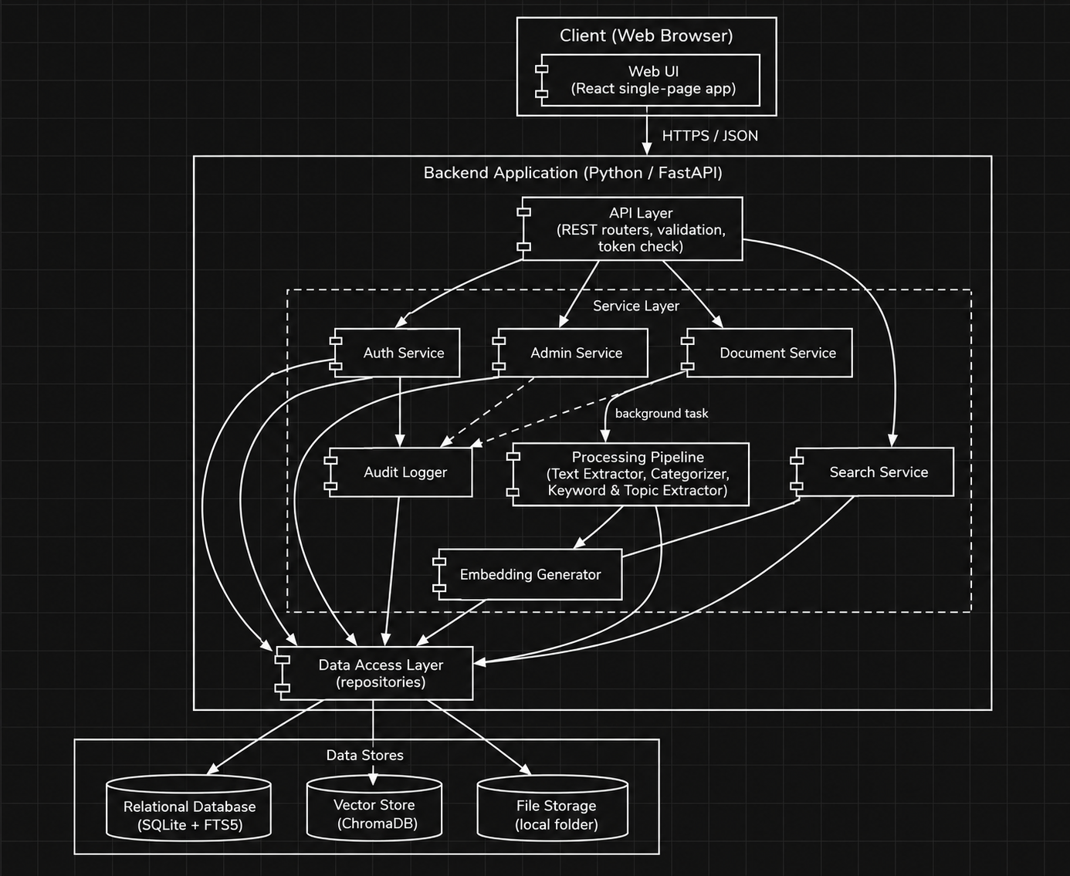
Figure 1: UML component diagram of AI-CMS

3.3.2 Class diagram (data model)
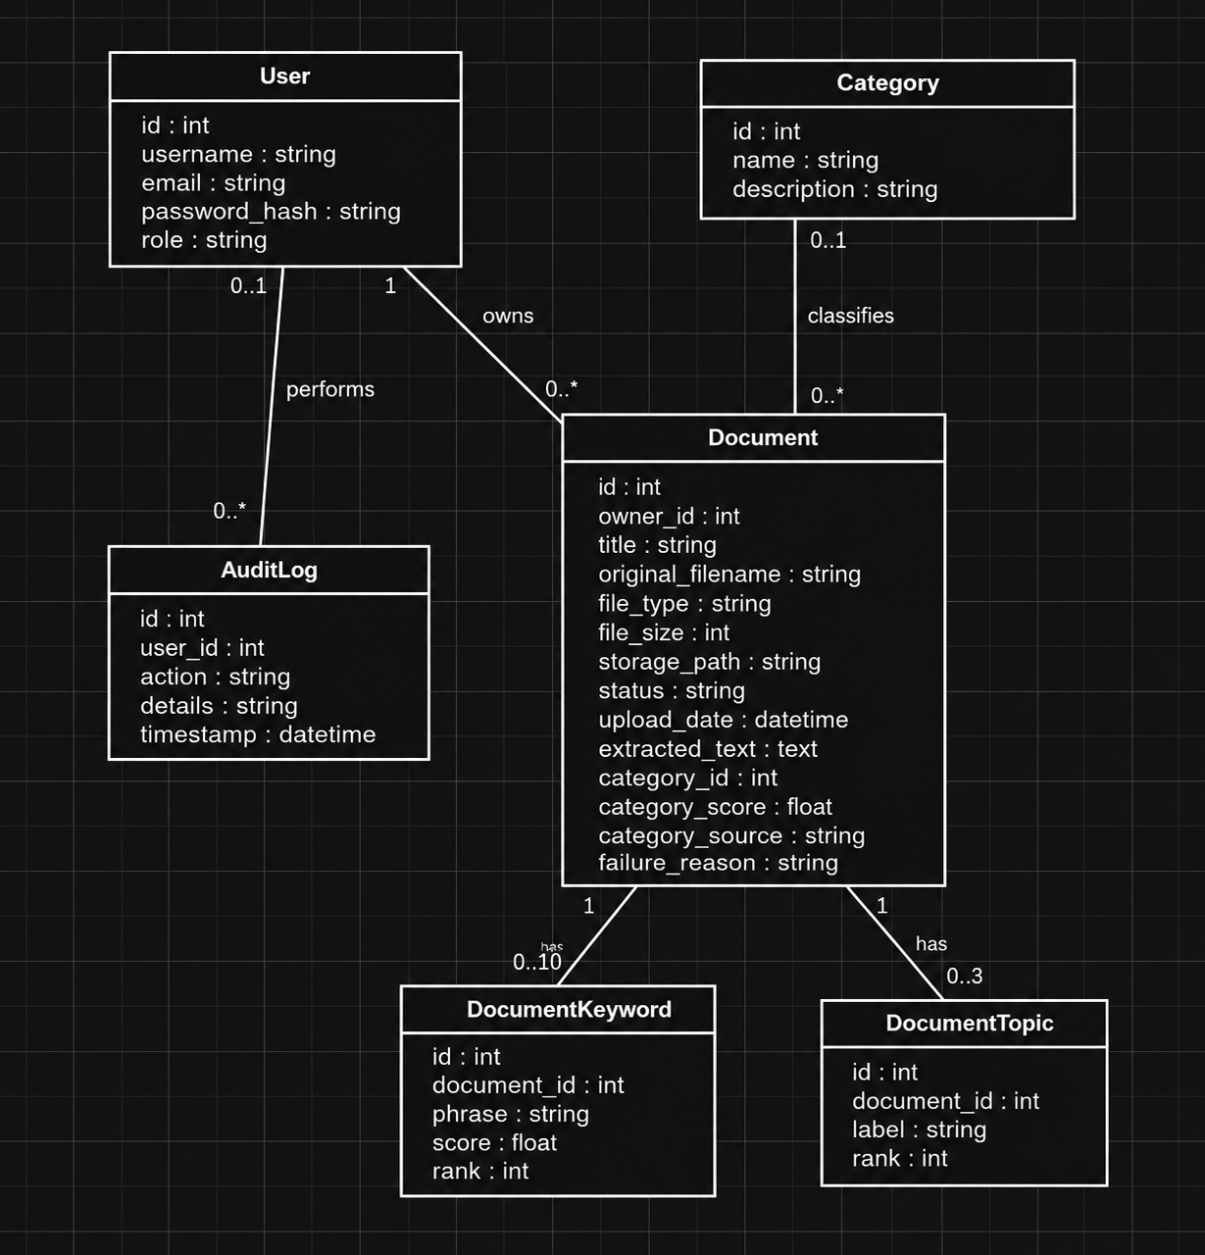
Figure 2: UML class diagram of the persistent data model
The passage embeddings are stored in the vector store (not in the relational database). Each embedding record contains the passage text, the document id and the passage number, and is linked to the document by the document id.

3.4 Component Descriptions
Component | Design Spec ID | Responsibility | Depends on
Web UI | DS-UI-01 | Single-page web application. Shows login/register, document list and upload form, document details, search page with filters and results, and administrator pages. Sends REST requests and keeps the access token in memory. | API Layer
API Layer | DS-Sec-01 | REST endpoints (FastAPI routers). Validates input types and lengths, checks the access token and role through a common dependency, calls services and converts errors to the standard error format. | Services
Auth Service | DS-Auth-01, DS-Auth-02 | Registration, password hashing (bcrypt), login, token issue and revocation (logout), role and ownership checks. | Data Access Layer, Audit Logger
Document Service | DS-Doc-01 | Upload handling and validation (extension, content signature, size), file storage under generated names, metadata, list, details, download, edit, delete (including removal of index entries), starts background processing. | Data Access Layer, Processing Pipeline, Audit Logger
Processing Pipeline | DS-Proc-01 | Controls processing of one document as a background task: sets status, calls the steps in order, handles failures (status Failed with reason), supports reprocessing, and at start-up marks documents left in Processing as Failed. | Text Extractor, Categorizer, Keyword & Topic Extractor, Embedding Generator
Text Extractor | DS-Proc-02 | Reads the stored file and returns plain text: PDF (text-based, with a PDF text library), DOCX (python-docx), TXT (UTF-8 with fallback). Raises an error with a reason when no text is found, file is corrupted or password protected. | File Storage
Categorizer | DS-Proc-03 | Compares the document embedding (mean of its passage embeddings) with the embedding of each category (name plus description). Picks the highest cosine similarity; if below the threshold the result is Uncategorized. Stores category and score. | Embedding Generator, Data Access Layer
Keyword & Topic Extractor | DS-Proc-04 | Extracts up to 10 key phrases (KeyBERT-style: candidate 1-2 word phrases ranked by similarity to the document embedding, with diversity). Groups the top candidate phrases into up to 3 clusters and uses the best phrase of each cluster as the topic label. | Embedding Generator
Embedding Generator | DS-Proc-05 | Loads the pre-trained sentence-embedding model once at start-up. Splits text into passages, converts passages and queries to vectors, and writes passage vectors to the vector store. | Vector Store
Search Service | DS-Srch-01, DS-Srch-02, DS-Srch-03 | Keyword search (full-text index), semantic search (query embedding and vector similarity), applying owner and filter restrictions, grouping passages by document, relevance threshold, ranking, snippets and pagination. | Data Access Layer, Embedding Generator
Admin Service | DS-Adm-01, DS-Adm-02 | Add and delete categories (and recompute category embeddings when one is added), list the audit log. All functions require the Administrator role. | Data Access Layer, Audit Logger
Audit Logger | DS-Aud-01 | Writes security-relevant events (time, user, action, short details) to the audit table and to the application log, without sensitive data. | Data Access Layer
Data Access Layer | DS-Dat-01 | Repository classes that perform all database, vector store and file operations using an ORM and parameterised queries. | Relational database, Vector Store, File Storage
Configuration | DS-Cfg-01 | Reads settings and secrets from environment variables / a .env file (signing key, thresholds, limits, paths). Not stored in source code. | -

3.5 Chosen Architecture Pattern and Rationale
A layered monolithic architecture is chosen: a single back-end application with an API layer, a service layer and a data access layer, plus a separate browser front end. The AI functions are ordinary Python modules inside the service layer. Layers give a clear separation of concerns, allow each module to be unit tested without the others, and are easy for a small team to divide among members. Microservices were rejected because they add deployment, networking and debugging effort that is not justified by the size of this project (one server, few users). Document analysis is run as a background task of the same application instead of a separate worker system.
Architecture decisions (ADR summary):
ADR | Decision | Alternatives considered | Reason
ADR-01 | Layered monolith with REST API | Microservices | Simplicity and feasibility for a student team; sufficient for 10 users.
ADR-02 | Python and FastAPI for the back end | Java Spring Boot, Node.js | NLP and embedding libraries are mainly in Python; one language for API and AI code.
ADR-03 | Pre-trained sentence-embedding model (all-MiniLM-L6-v2, 384 dimensions) run locally | Cloud embedding API, larger models | Free, small (about 90 MB), fast on CPU, no document leaves the server.
ADR-04 | Category assignment by similarity between document and category embeddings | Training a classifier; calling a generative model | No labelled training set is needed; administrator can add categories by writing a description; easy to explain and test.
ADR-05 | ChromaDB (embedded mode) as vector store | FAISS, pgvector, own NumPy search | Runs inside the application without a server, stores metadata with vectors, supports restricting a query to a list of document ids and deleting by id.
ADR-06 | SQLite with FTS5 as relational database and keyword index | PostgreSQL, MySQL | No installation, one file, full-text search built in; the ORM allows later change to PostgreSQL.
ADR-07 | Processing with FastAPI background tasks | Celery with Redis | No extra services; adequate for a small number of documents.
ADR-08 | JWT access tokens with 30-minute expiry and a revocation table for logout | Server-side sessions | Stateless checks, simple to test with API tools; revocation list supports FR-003.

3.6 Technology Stack & Data Stores
Area | Technology | Purpose
Front end | React with Vite, Axios, plain CSS | Single-page user interface.
Back end | Python 3.10+, FastAPI, Uvicorn, Pydantic, SQLAlchemy | REST API, validation, ORM.
Security | passlib (bcrypt), python-jose (JWT), python-magic or signature check | Password hashing, tokens, file signature check.
Text extraction | pdfplumber (PDF), python-docx (DOCX) | Plain text extraction.
AI / NLP | sentence-transformers (all-MiniLM-L6-v2), KeyBERT, scikit-learn (KMeans), NumPy | Embeddings, keyword extraction, topic grouping, similarity.
Relational database | SQLite 3 with FTS5 | Users, documents, categories, keywords, topics, audit log, revoked tokens, full-text index.
Vector store | ChromaDB (persistent, embedded) | Passage embeddings and similarity search.
File storage | Local folder (outside the served static files) | Original uploaded files.
Deployment | Uvicorn behind a reverse proxy (for example Nginx or Caddy) providing HTTPS | TLS 1.2+ for the deployed demo; local development may use HTTP.

Data stores
Relational database (SQLite). Main tables: users, documents, categories, document_keywords, document_topics, audit_log, revoked_tokens, and a full-text virtual table documents_fts (title and extracted text). Data are stored as shown in Figure 2.
Vector store (ChromaDB). One collection, passages. Each record has an id (documentId_passageNumber), the 384-value embedding, the passage text, and metadata (document_id, passage_no). Its purpose is to find the passages most similar in meaning to a query, which is what makes semantic search possible. For 100 documents of about 70 passages each, the store holds at most about 7,000 vectors, which a laptop can search quickly without special infrastructure. Owner, category and date restrictions are applied by looking up the allowed document ids in the relational database first and passing them to the vector query.
File storage. Original files are saved as storage/<uuid>.<ext>. The original file name is kept only as metadata in the database.

Configuration parameters (initial values, tuned during testing)
Parameter | Initial value | Used by
Maximum upload size | 10 MB | Document Service (FR-006)
Passage size / overlap | 150 words / 30 words | Embedding Generator
Maximum passages embedded per document | 100 | Embedding Generator (first 100 passages; whole text still keyword indexed)
Category threshold | 0.30 cosine similarity | Categorizer (FR-015)
Semantic relevance threshold | 0.25 cosine similarity | Search Service (FR-022)
Passages retrieved per semantic query | 30 | Search Service
Keywords per document / topics per document | 10 / 3 | Keyword & Topic Extractor
Token lifetime | 30 minutes | Auth Service (FR-003)
Page size | 10 | Document list, search, audit log

3.7 Risks & Mitigations
Risk | Mitigation
Categorization or semantic search quality is lower than the targets (NFR-003, NFR-004). | Tune thresholds on a separate development set; write clear category descriptions; allow manual category correction (FR-012); keep the model replaceable.
Processing is slow on laptops without GPU (NFR-002). | Small model, limit of 100 passages per document, model loaded once, processing in the background.
PDF files without extractable text (scans) or corrupted files. | Detect empty extraction, set status Failed with a clear reason; OCR documented as future work.
Model download or library version problems on team machines. | Pin library versions in requirements.txt; document installation; keep the model files in a shared folder.
Background task lost when the server restarts. | At start-up, documents in Processing are set to Failed and can be reprocessed (NFR-006, FR-019).
Index inconsistency between database and vector store after errors. | Delete and reprocess operations remove all index entries of a document first; unit tests check this.
Time and team size limits. | Small component set, one language for the back end, features prioritised (High priority requirements first).

3.8 Traceability to Requirements
Each requirement of the SRS is assigned to the component(s) that implement it and to a design specification ID (DS-...) defined in Section 3.4 (DS-Dat-01 supports every persistent function and is not repeated).
Req ID | Requirement (short) | Component(s) | Design Spec
FR-001 | User registration | Auth Service | DS-Auth-01
FR-002 | User login | Auth Service | DS-Auth-01
FR-003 | Logout and session expiry | Auth Service | DS-Auth-01
FR-004 | Role-based access control | Auth Service | DS-Auth-02
FR-005 | Document upload | Document Service | DS-Doc-01
FR-006 | File validation | Document Service | DS-Doc-01
FR-007 | Document storage and metadata | Document Service | DS-Doc-01
FR-008 | Document list | Document Service | DS-Doc-01
FR-009 | View document details | Document Service | DS-Doc-01
FR-010 | Download document | Document Service | DS-Doc-01
FR-011 | Delete document | Document Service | DS-Doc-01
FR-012 | Edit title and category | Document Service | DS-Doc-01
FR-013 | Text extraction | Text Extractor | DS-Proc-02
FR-014 | Automatic processing and status | Processing Pipeline | DS-Proc-01
FR-015 | Automatic categorization | Categorizer | DS-Proc-03
FR-016 | Keyword extraction | Keyword & Topic Extractor | DS-Proc-04
FR-017 | Topic extraction | Keyword & Topic Extractor | DS-Proc-04
FR-018 | Embedding generation and indexing | Embedding Generator | DS-Proc-05
FR-019 | Reprocess document | Processing Pipeline | DS-Proc-01
FR-020 | Keyword search | Search Service | DS-Srch-01
FR-021 | Natural-language semantic search | Search Service | DS-Srch-02
FR-022 | Result ranking and presentation | Search Service | DS-Srch-03
FR-023 | Search filters | Search Service | DS-Srch-03
FR-024 | Category management | Admin Service | DS-Adm-01
FR-025 | Audit log view | Admin Service | DS-Adm-02
NFR-001 | Search response time | Search Service | DS-Srch-02
NFR-002 | Document processing time | Processing Pipeline | DS-Proc-01
NFR-003 | Categorization accuracy | Categorizer | DS-Proc-03
NFR-004 | Semantic search relevance | Search Service | DS-Srch-02
NFR-005 | Usability | Web UI | DS-UI-01
NFR-006 | Reliability and error recovery | Processing Pipeline | DS-Proc-01
NFR-007 | Maintainability | All back-end modules | DS-Cfg-01
NFR-008 | Portability and compatibility | Web UI / Back-end | DS-Cfg-01
SR-001 | TLS for all connections | Deployment configuration | DS-Cfg-01
SR-002 | Password protection | Auth Service | DS-Auth-01
SR-003 | Token authentication | Auth Service / API Layer | DS-Auth-01
SR-004 | Server-side authorization | Auth Service / API Layer | DS-Auth-02
SR-005 | Safe file upload | Document Service | DS-Doc-01
SR-006 | Injection protection | API Layer / Data Access Layer / Web UI | DS-Sec-01
SR-007 | Audit logging | Audit Logger | DS-Aud-01
SR-008 | Secret management | Configuration | DS-Cfg-01

